*--Explanation of trip details (longer than 10 hours reminder):*

SELECT Flight_Number, Airline_Name, Flight_Source, Flight_Destination, Flight_Duration

FROM Dim_Flight

WHERE Flight_Duration > 10;

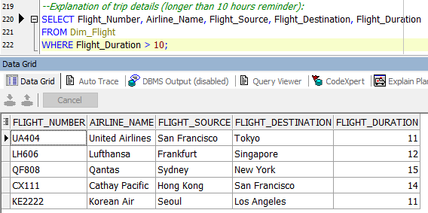

*--Featured Customer Analysis:*

*--Show customers with total miles above 100,000 miles with “Gold” status or higher:*

SELECT Namee, Status, Total_Miles, Frequent_Flyer_Segment, Country

FROM Dim_Frequent_Flyer

WHERE Total_Miles > 100000 AND (Status = 'Gold' OR Status = 'Platinum');

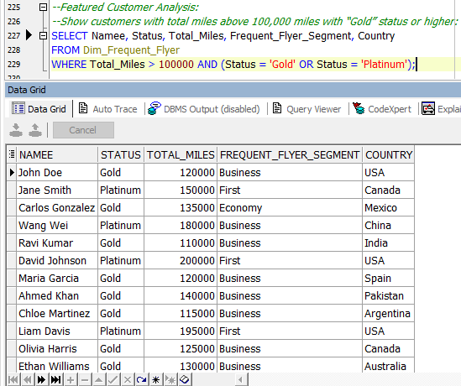

*--Customer Service Issue Analysis:*

*--Show customer service issues that have not been resolved yet:*

SELECT Interaction_Type, Problem_Severity, Channel, Resolution_Status

FROM Dim_Customer_Care

WHERE Resolution_Status = 'Unresolved';

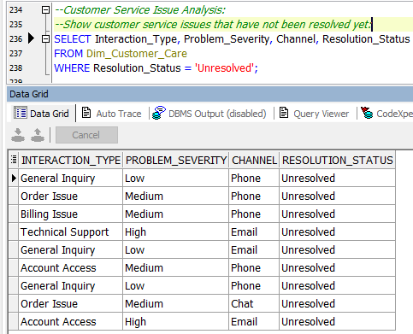

--Booking Inquiries:

--Display details of confirmed bookings only:

SELECT Reservation_Channel, Booking_Date, Ticket_Class, Payment_Method

FROM Dim_Reservation

WHERE Reservation_Status = 'Confirmed';

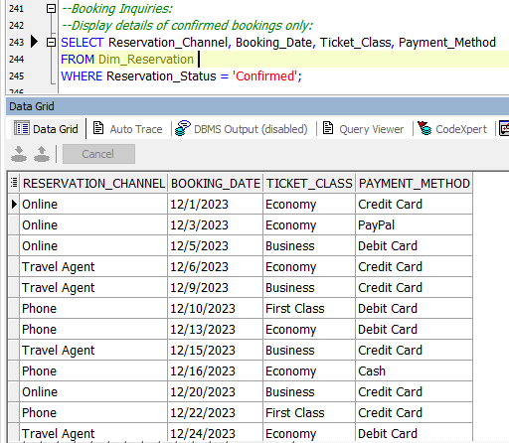

*--Total confirmed bookings per booking channel:*

SELECT Reservation_Channel, COUNT(*) AS Total_Confirmed

FROM Dim_Reservation

WHERE Reservation_Status = 'Confirmed'

GROUP BY Reservation_Channel;

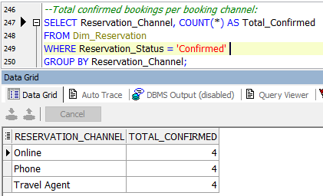

*--Price Analysis:*

*--Show average ticket price for each type of service:*

SELECT Class_of_Service, AVG(Price) AS Average_Price

FROM Dim_Fare

GROUP BY Class_of_Service;

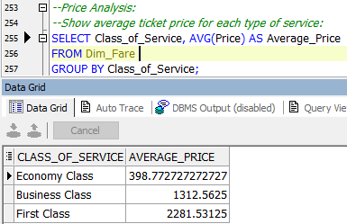

*--Data Merge Queries:*

*--Show details of trips taken by Platinum customers only:*

SELECT ff.Namee, ff.Status, f.Flight_Number, f.Airline_Name, f.Flight_Source, f.Flight_Destination

FROM Factless_Table ft

JOIN Dim_Frequent_Flyer ff ON ft.Frequent_Flyer_ID = ff.Frequent_Flyer_ID

JOIN Dim_Flight f ON ft.Flight_ID = f.Flight_ID

WHERE ff.Status = 'Platinum';

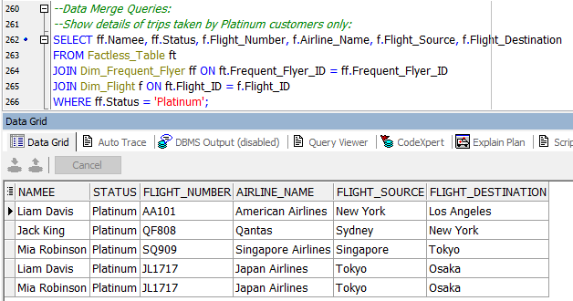

*--Customer Service Response Time Analysis:*

*-- Show average response time for each type of interaction:*

SELECT Interaction_Type, AVG(TO_NUMBER(REGEXP_SUBSTR(Response_Time, '^\d+'))) AS Average_Response_Time

FROM Dim_Customer_Care

GROUP BY Interaction_Type;

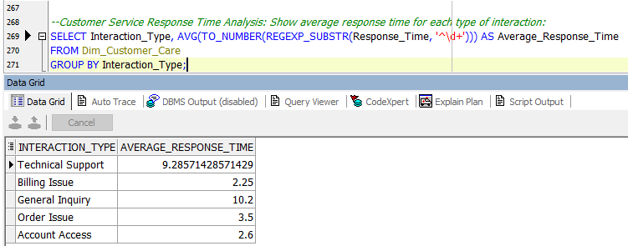

--Seasonality Analysis:

--Show prices based on seasonality and service type:

SELECT Seasonality, Class_of_Service, AVG(Price) AS Average_Price

FROM Dim_Fare

GROUP BY Seasonality, Class_of_Service;

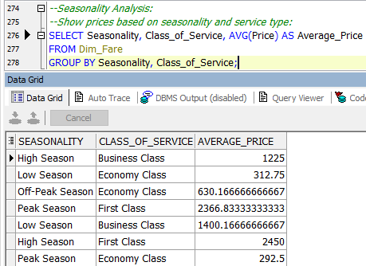

*--Full Data Analysis Query:*

*---Full details about customers, trips, bookings, and prices:*

*SELECT*

*ff.Namee AS Frequent_Flyer_Name,*

*f.Flight_Number, f.Airline_Name,*

*r.Reservation_Channel, r.Ticket_Class,*

*fare.Price, fare.Seasonality*

*FROM Factless_Table ft*

*JOIN Dim_Frequent_Flyer ff ON ft.Frequent_Flyer_ID = ff.Frequent_Flyer_ID*

*JOIN Dim_Flight f ON ft.Flight_ID = f.Flight_ID*

*JOIN Dim_Reservation r ON ft.Reservation_ID = r.Reservation_ID*

*JOIN Dim_Fare fare ON ft.Fare_Basis = fare.Fare_Basis;*

